1. Design an HTML page to display as given below using CSS3 Linear gradient.



2. Design an HTML page to display as given below using different directions for CSS3 Linear gradient.



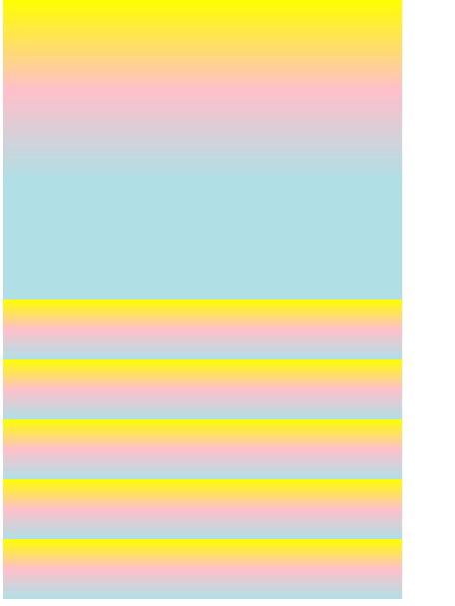

3. Design an HTML page to display as given below to set the transition-property of background and border for 1 sec and 2 sec durations respectively and a color of your choice for the background and border of a button with text “Hover on me”.





4. Design an HTML page using transparency for linear gradient.

